【例4-67】增加图像的渲染效果
I = imread('eight.tif');
J = imnoise(I,'salt & pepper',0.02);
imshow(I)
figure, imshow(J)
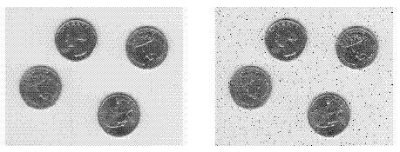
图像的渲染效果

